# CS 255 System Design Document Template

## UML Diagrams

### UML Use Case Diagram

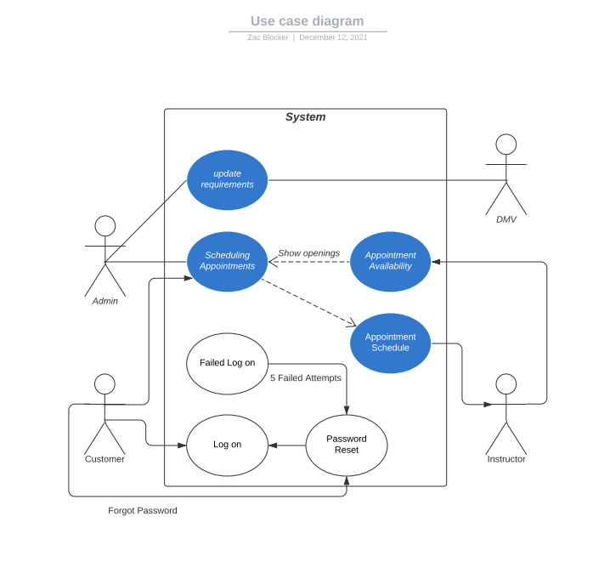

### UML Activity Diagrams

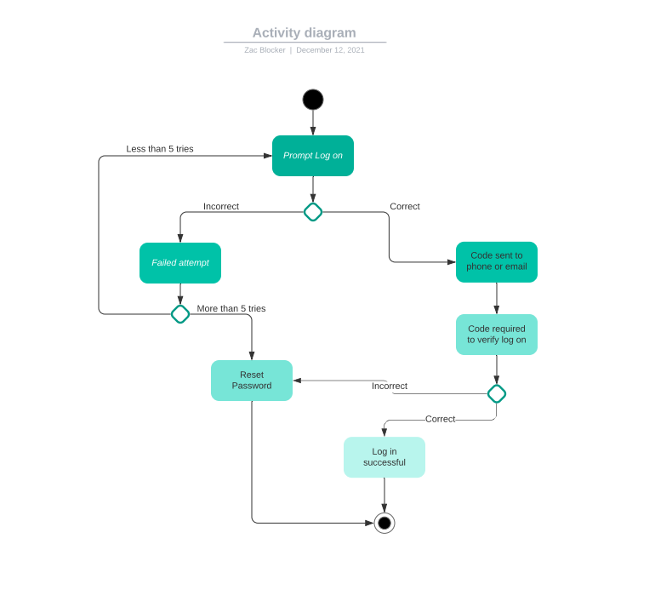

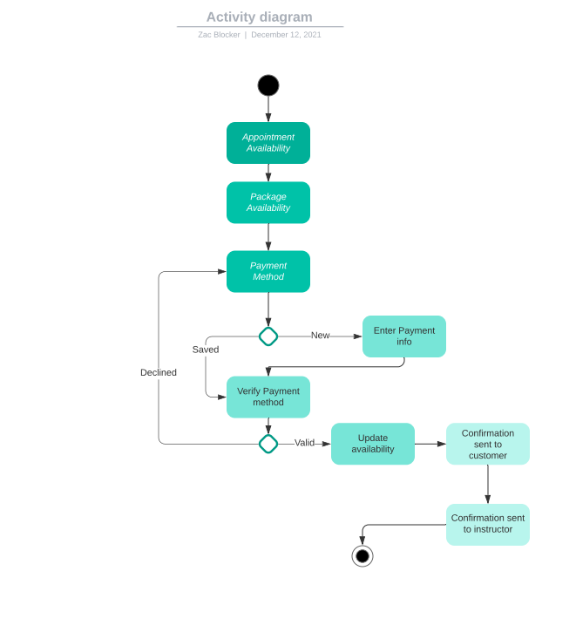

### UML Sequence Diagram

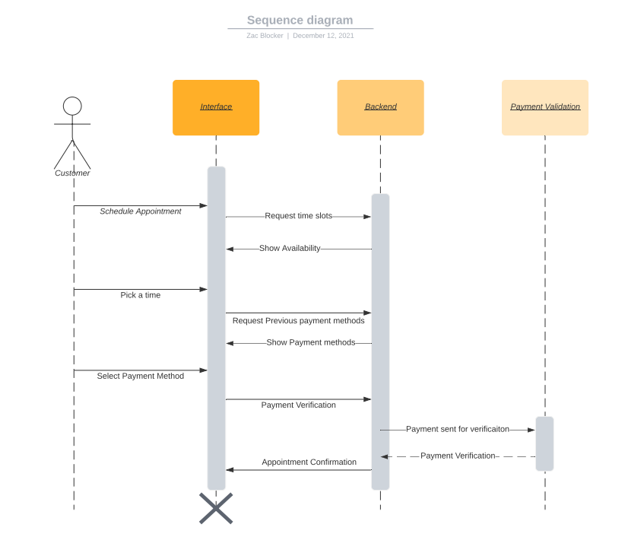

### UML Class Diagram

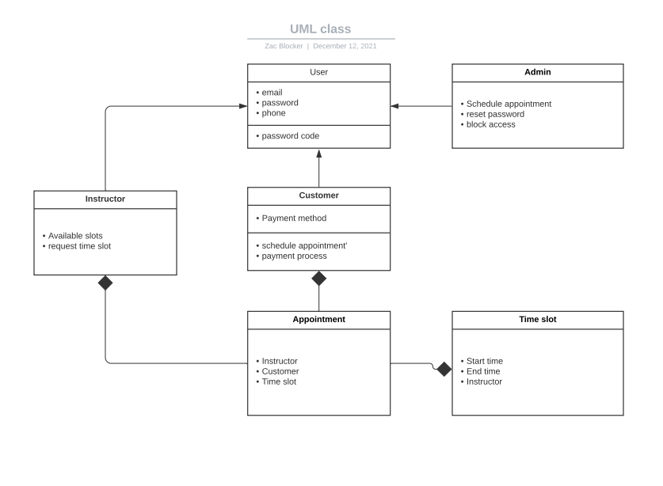

## Technical Requirements

* *Internet Connection with access to the web browser of choice*
* *Payment processing abilities*
* *Server capable of running the backend and user interface*
* *Website hosting service*
* *SSL certificate*
* *Mobile design*